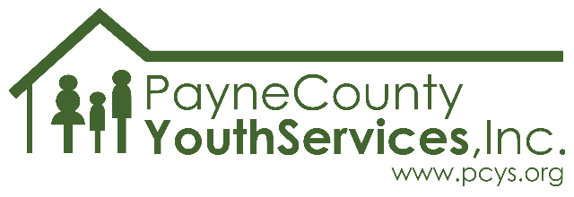
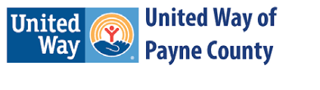

2022-2023 School Year
Theme: Gen Z: Still We Rise

What is it?
Voices of Today is an annual imagery, poetry, and photography contest offered by Payne County Youth Services.

Who can participate?
Any 6th through 12th grader in Payne County.

How much does it cost?
It’s FREE, just like all services offered by PCYS!

Why should I participate?
Glad you asked!
- You’ll have your art displayed in the community! (With parent/guardian permission, of course.)
- You could win! In each category a 1st, 2nd, and 3rd place winner will be chosen from each school and grade level (so you’ll be competing only against students in the same grade and at the same school as you). There will also be a “Best in Show” awarded in each category - this prize goes to the overall best entry in imagery, poetry, or photography (all schools/grade levels compete for this award).
- Your voice matters! Youth art presents an important and unique opportunity for the community to connect with young people. Show the community what you think, how you feel, what’s important to you through your submission!

What are the rules?
Here are the basics – additional, important details are listed on the back of this page.
- All submissions must be original to the artist. No copyrighted or previously published work is allowed.
- Categories: Imagery (drawing, painting, comic art, digital art, collage), Poetry, Photography
- Entries are due in school or at the PCYS office no later than December 16th, 2022.
- Entries must address this year’s theme: Gen Z: Still We Rise (you can add an explanation if you like).
- Formatting for all categories:
  - Submissions must not exceed the dimensions of 18”X24” (note: standard poster board is 22”X28”).
  - Artwork must be completed on a paper product or canvas (no frames allowed).
  - Any piece submitted that is not on paper/canvas (wood, glass, metal, etc.) will not be judged.
  - Submissions should be mounted on heavy paper/poster board/cardstock/matboard and must be ready for display at the time of submission.

IMPORTANT DETAILS:

- TURN IN YOUR SUBMISSION NO LATER THAN FRIDAY DECEMBER 16, 2022.
  - Submissions may be turned in to designated staff at the school site, or delivered directly to Payne County Youth Services at 2224 W. 12th Ave, Stillwater, OK 74074
    - An image of the submission and permission form may be submitted electronically via email to kims@pcys.org.
  - Submission must be received by a school/PCYS before close of business on 12/16/2022.
  - Artwork submitted/received after the deadline will not be admissible.
- EACH ENTRY must have a signed parent/guardian permission form attached (to the back) and the appropriate box checked in the “Artwork Information” section of the form before the piece can be publicly displayed.
  - Art submitted without the permission form will be accepted and judged but will NOT be displayed publicly or used for publicity purposes unless written permission is obtained.
- Each artist may submit up to three entries per category (maximum number of entries if entering in all three categories = nine).
- In regard to addressing the theme “Gen Z: Still We Rise” - The artist is welcome to include a “Description of Submission” to explain how their piece addresses the theme if the artist would like to do so.
  - Description of Submission should be no more than 1-3 sentences long and should be secured to the back of the piece.
- Submissions will be displayed in select locations in Payne County beginning in March 2023.
  - Once all submissions are received, we’ll let you know where to look for (and show off) your piece!
    - Please make sure a parent/guardian email address is included on your permission form to receive this information or
      - check the PCYS Facebook page in March for a list of display locations.
      - ask your school site for a list of display locations.
- The artist may choose to have their artwork returned to them after the contest or to donate their piece to PCYS either to be auctioned off at a fundraising event or to be displayed indefinitely at a PCYS facility.
  - Artwork that is not donated may be picked up at the PCYS office between May 1st and May 31st, 2023. (Schools/Teachers may request to have art returned to the school/classroom for distribution to participants.)
  - Any and all proceeds from donated artwork will directly benefit services provided to the community by PCYS.

Note: PCYS will take reasonable precautions to protect the artwork; however, PCYS is NOT liable for any lost, stolen, or damaged submissions. All artwork must be original and not in proximity of a recognizable copyrighted work. Artwork found to be in violation of copyright laws will be removed from the competition.

Email kims@pcys.org with questions about this program.

We can’t wait to see your art!

