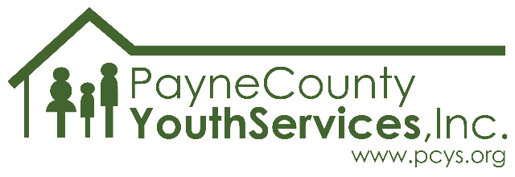
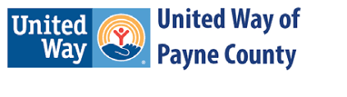

2023-2024 School Year
Theme: A.I. & Art: #stillhuman

What is it?
Voices of Today is an annual imagery, poetry, and photography contest offered by Payne County Youth Services.

Who can participate?
Any 6th through 12th grader in Payne County.

How much does it cost?
It’s FREE, just like all services offered by PCYS!

Why should I participate?
Glad you asked!
- You’ll have your art displayed in the community! (With parent/guardian permission, of course.)
- You could win! In each category a 1st, 2nd, and 3rd place winner will be chosen from each school and grade level (so you’ll be competing only against students in the same grade and at the same school as you). There will also be a “Best in Show” awarded in each category - this prize goes to the overall best entry in imagery, poetry, or photography (all schools/grade levels compete for this award).
- Your voice matters! Youth art presents an important and unique opportunity for the community to connect with young people. Show the community what you think, how you feel, what’s important to you through your submission!

What are the rules?
Here are the basics – additional, important details are listed on the back of this page.
- All submissions must be original to the artist. No copyrighted or previously published work is allowed.
- Categories: Imagery (drawing, painting, comic art, digital art, collage), Poetry, Photography
- Entries are due in school or at the PCYS office no later than December 15th, 2023.
- Entries must address this year’s theme: A.I. & Art: #stillhuman (you can add an explanation if you like).
- Formatting for all categories:
  - Submissions must not exceed the dimensions of 18”X24” (note: standard poster board is 22”X28”).
  - Artwork must be completed on a paper product or canvas (no frames allowed).
  - Any piece submitted that is not on paper/canvas (wood, glass, metal, etc.) will not be judged.
  - Submissions should be mounted on heavy paper/poster board/cardstock/matboard and must be ready for display at the time of submission.

IMPORTANT DETAILS:

- TURN IN YOUR SUBMISSION NO LATER THAN FRIDAY DECEMBER 15, 2023.
  - Submissions may be turned in to designated staff at the school site, or delivered directly to Payne County Youth Services at 2224 W. 12th Ave, Stillwater, OK 74074
    - An image of the submission and permission form may be submitted electronically via email to kims@pcys.org.
  - Submission must be received by a school/PCYS before close of business on 12/15/2023.
  - Artwork submitted/received after the deadline will not be admissible.
- EACH ENTRY must have a signed parent/guardian permission form attached (to the back) and the appropriate box checked in the “Artwork Information” section of the form before the piece can be publicly displayed.
  - Art submitted without the permission form will be accepted and judged but will NOT be displayed publicly or used for publicity purposes unless written permission is obtained.
- Each artist may submit up to three entries per category (maximum number of entries if entering in all three categories = nine).
- In regard to addressing the theme “A.I. and Art: #stillhuman” - The artist is welcome to include a “Description of Submission” to explain how their piece addresses the theme if the artist would like to do so.
  - Description of Submission should be no more than 1-3 sentences long and should be secured to the back of the piece.
- Submissions will be displayed in select locations in Payne County beginning in March 2024.
  - Once all submissions are received, we’ll let you know where to look for (and show off) your piece!
    - Please make sure a parent/guardian email address is included on your permission form to receive this information or
      - check the PCYS Facebook or Instagram page in March for a list of display locations.
      - ask your school site for a list of display locations.
- The artist may choose to have their artwork returned to them after the contest or to donate their piece to PCYS either to be auctioned off at a fundraising event or to be displayed indefinitely at a PCYS facility.
  - Artwork that is not donated may be picked up at the PCYS office between May 6th and May 31st, 2024. (Entries turned in by a school will be returned to that school/classroom for distribution to participants.)
  - Any and all proceeds from donated artwork will directly benefit services provided to the community by PCYS.

Note: PCYS will take reasonable precautions to protect the artwork; however, PCYS is NOT liable for any lost, stolen, or damaged submissions. All artwork must be original and not in proximity of a recognizable copyrighted work. Artwork found to be in violation of copyright laws will be removed from the competition.

Email kims@pcys.org with questions about this program.

We can’t wait to see your art!

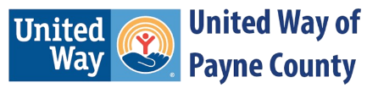
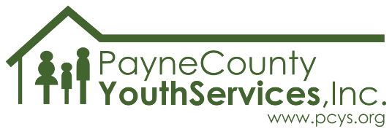

2023-2024 Theme: A.I. & Art: #stillhuman
artist information
This completed form MUST accompany EACH submission.
Artist first and last name:
Age: | Email address:
Mailing address:
School name: |  | Grade:
Teacher/facilitator’s name:
Teacher/facilitator’s email address:
Parent/guardian first and last name:
Parent/guardian phone: | Parent/guardian email address:
Artwork information
Title of submission:
Entered as (select one category): ☐Art/Imagery ☐Poetry ☐Photography
Description of submission:
Date and location submitted:
Copyright release
As a contestant, I hereby grant consent to Payne County Youth Services, Inc. the exclusive right and permission, in respect of the original artwork that I have submitted to the Payne County Youth Services, Inc. Art, Poetry and Photography Contest, to display the artwork on a display board and to be displayed in various local communities within Payne County area.

If I am selected as a contest WINNER, I hereby consent to Payne County Youth Services Inc. the right and permission to use, publish, and reproduce and display in any and all media now or hereafter known throughout the promotion of the contest at the agency. By my signature I grant permission to Payne County Youth Services, Inc., to publish in all print and electronic media, the artist’s name, age, and city as per parental permission. In any of the winning categories, Payne County Youth Services, Inc. maintains the exclusive right to declare no winner and withhold prizes if no artwork of merit is found. I understand that all artwork submitted to the Art, Poetry and Photography Contest will be returned to the artist (unless the artist chooses to donate it to PCYS).

I wish to donate my artwork to PCYS for possible indefinite display at a PCYS facility. ☐

I wish to donate my artwork to PCYS to be sold or auctioned at a PCYS fundraiser. ☐

Parent/Guardian/Adult signature and date: _____________________________________
This release is not required for contest entry but is required for public display and/or publication.

Artist’s signature and date: _____________________________________

Originality Confirmation: I declare that the artwork submitted to the Payne County Youth Services, Inc. Art, Poetry, and Photography Contest is my own original work and not copied from any existing artwork.
Artist’s signature and date: _____________________________________

The deadline to hand in artwork is 12/15/2023. Please turn in artwork to your school or you may drop off at the PCYS office: 2224 W 12th Ave., Stillwater, OK. Please call and ask for Kim Shenold at 405-377-3380 for additional information or email kims@pcys.org.
SCHOOL SITES: If you receive a submission, contact Kim to pick it up at your convenience. Thank you!

